**DynamoDB (An AWS Proprietary)**

* Fully Managed Highly Available with replication across 3 AZs
* It belongs to NoSQL database – **it is not a relational database**
* Scales to massive workloads, distributed ‘serverless’ database
* It handles millions of requests per second, trillions of rows, 100s of TB of storage
* Fast and consistent performance
* Single-digit millisecond latency – low latency retrieval
* Integrated with IAM for security, authorization and administration
* Has low cost and auto scaling capabilities
* Belongs to a Standard and Infrequent Access (IA) table class

**DynamoDB – type of Data:**

* DynamoDB is a key/value database

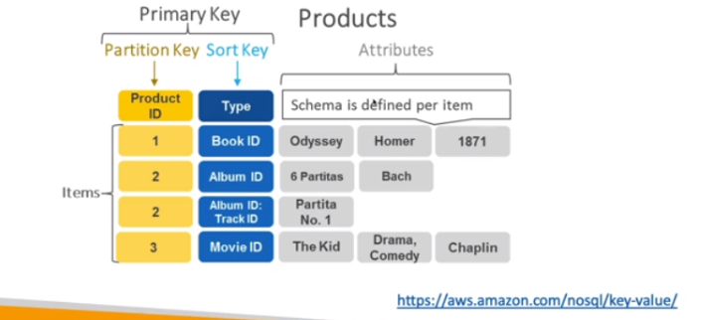

**DynamoDB Accelerator – DAX**

* Fully managed in-memory cache for DynamoDB
* DAX is just made for DynamoDB [not to be confused with ElastiCache]  
    
  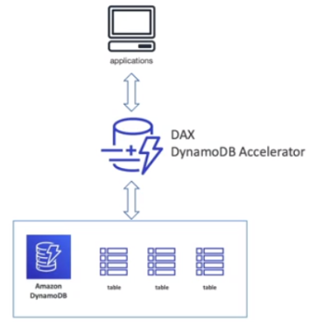
* **10x performance improvement –** single digit millisecond latency to microseconds latency – when accessing your DynamoDB tables
* Secure, highly scalable and highly available

**NOTE:**

* Difference between ElastiCache and DAX – DAX is only used for and is integrated with DynamoDB, while ElastiCache can be used for other databases
* **Relational Database** means two tables canbe joined but in **Non-Relational Database,** tables can’t be joined and they function independently

**DynamoDB – Global Tables**

* Make a DynamoDB table accessible with low latency in multiple-regions
* The read/write access to any AWS region makes it an **active-active** replication.

